Bahria University,

Karachi Campus



LAB EXPERIMENT NO.

**02**

LIST OF TASKS

|  |  |
| --- | --- |
| TASK NO. | OBJECTIVE |
| 1 | Design a multiple webpage including html and css include all css properties of text, border font etc. the following navigation tab must be added:Home, information, gallery & about. |
| 2 | Write a css that makes all font size 1.5 larger than the base font size of the system and colors the red text |
| 3 | Write a css that places a background image halfway down the page, tiling it horizontally, the image should remain in place when the user scrolls up or down. |
| 4 | Write a css rule that gives all h1 and h2 elements a padding and margin of 0.5em, dashed border style. |
| 5 | make a style sheet that display h1 in blue, in addition create a rule that displays all links in blue without underlining them. When the mouse hovers over a link, a change the links background color to yellow. |
| 6 | Make a navigation button with a link inside it, give it a border, background and text color, and make them change when the use of hovers the mouse over the button |

Submitted On:

**TASK 1:** Design a multiple webpage including html and css include all css properties of text, border font etc. the following navigation tab must be added:Home, information, gallery & about.

**CODE:**

<!DOCTYPE html>

<html>

<head>

    <meta charset="utf-8">

    <meta name="viewport" content="width=device-width, initial-scale=1">

    <title>University Website Design</title>

    <link rel="stylesheet" type="text/css" href="style.css">

    <link rel="preconnect" href="https://fonts.googleapis.com">

<link rel="preconnect" href="https://fonts.gstatic.com" crossorigin>

<link href="https://fonts.googleapis.com/css2?family=Poppins:wght@200;300;400;600;700&display=swap" rel="stylesheet">

<link rel="stylesheet" href="https://cdn.jsdelivr.net/npm/@fortawesome/fontawesome-free@5.15.4/css/fontawesome.min.css">

</head>

<body>

    <section class="header">

        <nav>

            <div class="nav-links" id="navlinks">

                <ul>

                    <li><a href="Home.html">HOME</a></li>

                    <li><a href="About.html">ABOUT</a></li>

                    <li><a href="Gallery.html">GALLERY</a></li>

                    <li><a href="contact.html">CONTACT</a></li>

                </ul>

            </div>

        </nav>

        <div class="text-box">

            <h1>World's Biggest University</h1>

            <p>Making Website is now one of the easiest thing in the world. You

                just need to learn HTML, CSS,<br>JavaScript and you are good to go.

            </p>

            <a href="" class="hero-btn">Visit Us To Know More</a>

        </div>

    </section>

</body>

</html>

**CSS:**

*{

    margin:  0;

    padding: 0;

    font-family: 'Poppins', sans-serif;

}

/* vh means viewport height and viewport width */

/* Relative - the element is positioned relative to its normal position.

   Absolute - the element is positioned absolutely to its first positioned parent */

.header{

    min-height: 100vh;

    width: 100%;

    background-image: linear-gradient(rgba(4, 9, 30, 0.7),

        rgba(4, 9, 30, 0.7)),url(images/banner.png);

    background-position: center;

    background-size: cover;

    position: relative;

}

nav{

    display: flex;

    padding: 2% 6%;

    justify-content: space-between;

    align-items: center;

}

.nav-links{

    flex: 1;

    text-align: right;

}

.nav-links ul li{

    list-style: none;

    display: inline-block;

    padding: 8px 12px;

    position: relative;

}

.nav-links ul li a{

    color: #fff;

    text-decoration: none;

    font-size: 13px;

}

.text-box{

    width: 90%;

    color: #fff;

    position: absolute;

    top: 50%;

    left: 50%;

    transform: translate(-50%, -50%);

    text-align: center;

}

.text-box h1{

    font-size: 62px;

}

.text-box p{

    margin: 10px 0 40px;

    font-size: 14px;

    color: #fff;

}

.hero-btn{

    display: inline-block;

    text-decoration: none;

    color: #fff;

    border: 1px solid #fff;

    padding: 12px 34px;

    font-size: 13px;

    background: transparent;

    position: relative;

    cursor: pointer;

}

.hero-btn:hover{

    border: 1px solid #f44336;

    background: #f44336;

    transition: 1s;

}

.text{

    color: #fff;

    position: relative;

    top: 50%;

    left: 50%;

    transform: translate(-50%, -50%);

}

.text h2{

    font-size: 35px;

    margin: 100px 0 0 40px;

}

.text p{

    margin: 20px 0 0 40px;

    font-size: 13px;

    color: #fff;

}

.text-col{

    position: absolute;

    top: 60%;

}

.text-col tr td p{

    margin: 10px 0 0 40px;

    font-size: 13px;

    color: #fff;

}

.head{

    color: #fff;

    font-size: 18px;

    justify-content: center;

}

.pics{

    margin-left: 10px;

    margin-right: 10px;

}

.pics tr{

    display: flex;

    flex-wrap: wrap;

}

.pics tr td img{

    margin: 10px 0 0 40px;

}

.cont{

    color: #fff;

    text-align: center;

    position: absolute;

    top: 50%;

    left: 50%;

    transform: translate(-50%, -50%);

}

.cont a {

    color: rgb(57, 185, 121)  ;

    background-color: transparent;

    text-decoration: none;

}

**OUTPUT:**



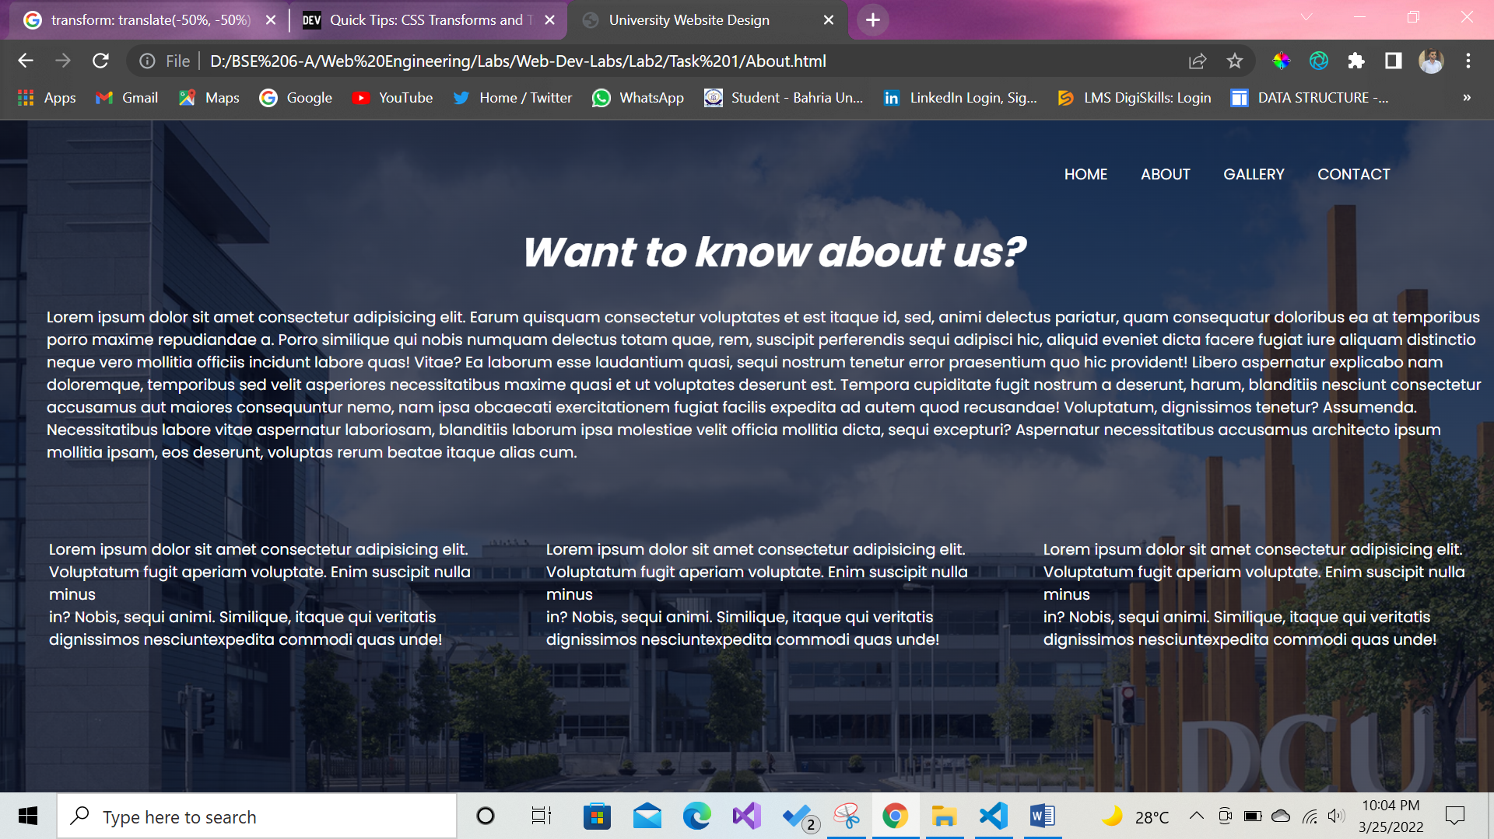

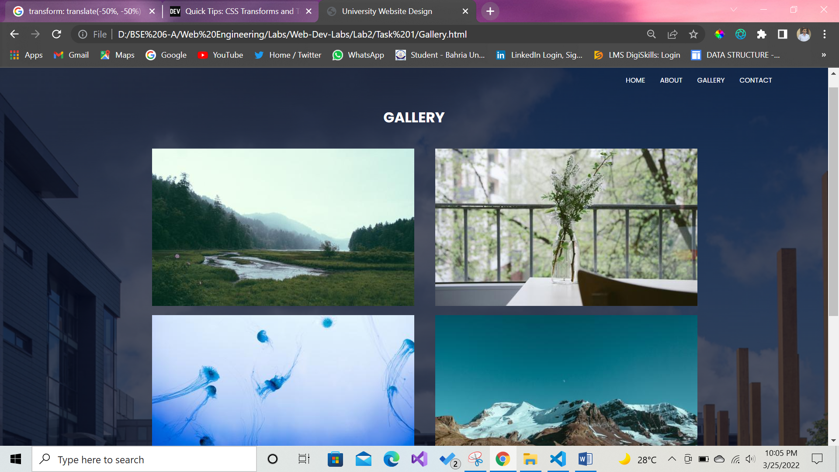

**WITH FLEX WRAP**

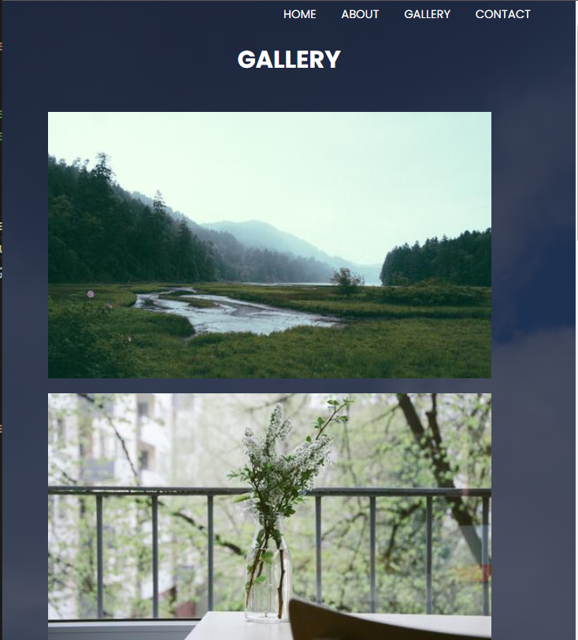

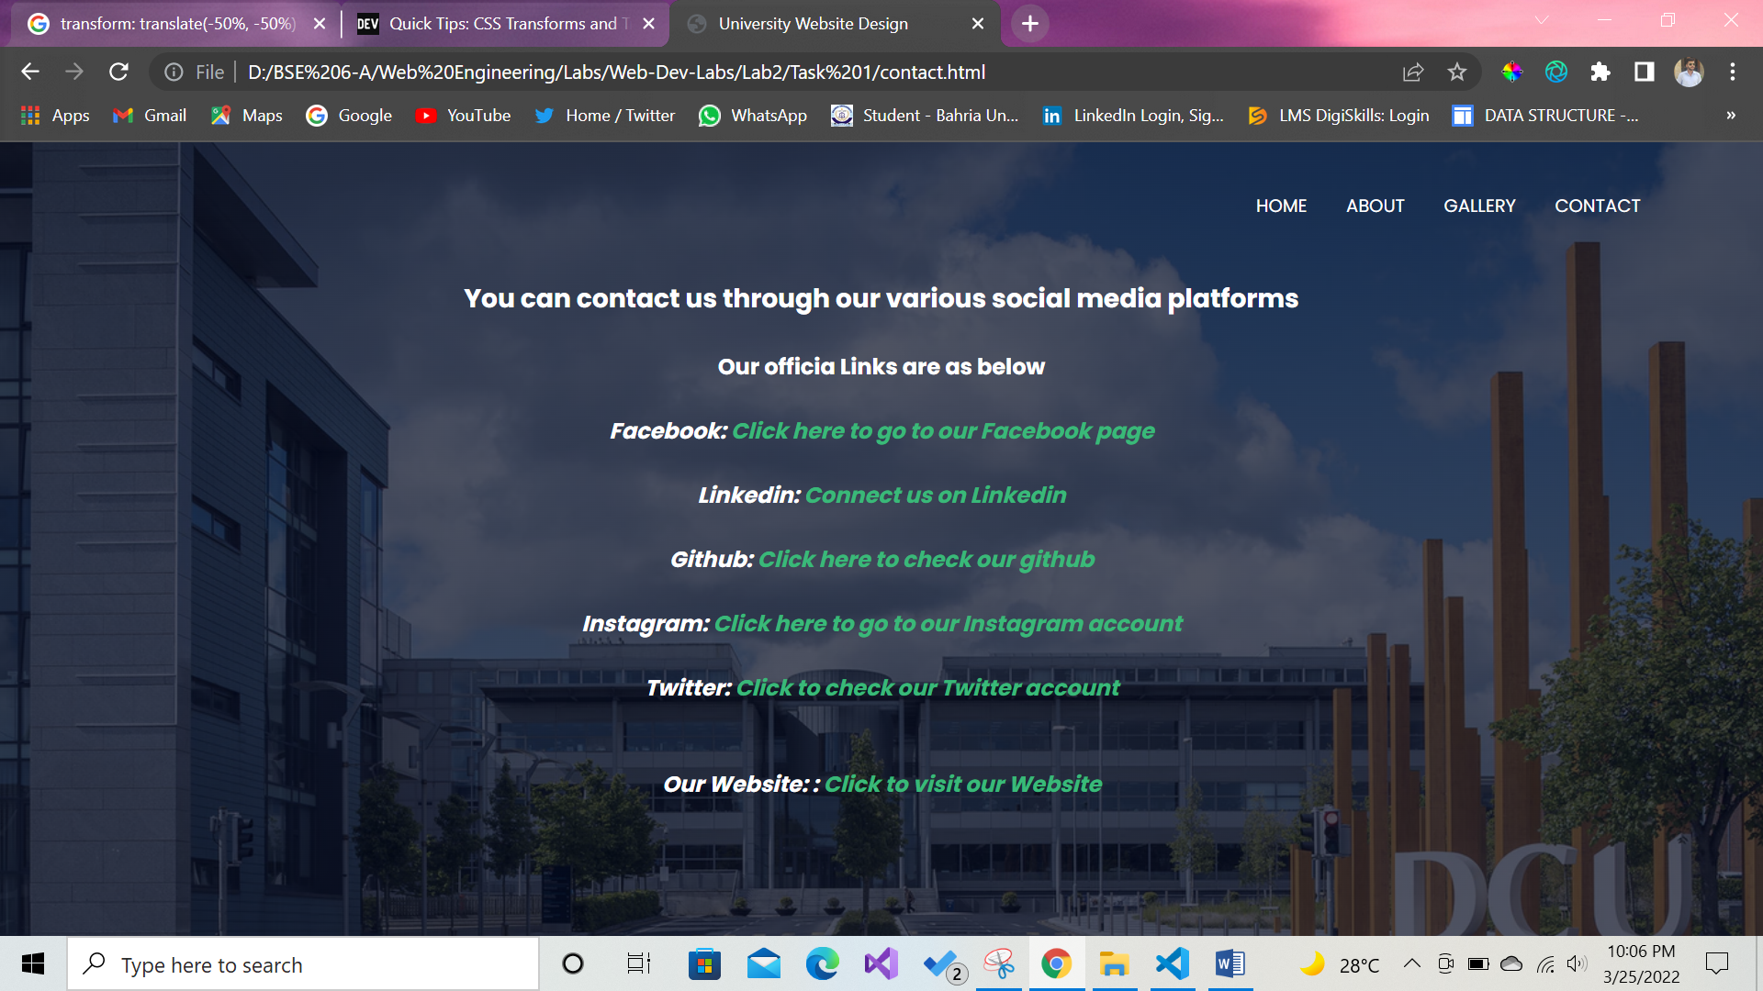

**TASK 2:** Write a css that makes all font size 1.5 larger than the base font size of the system and colors the red text

**CODE:**

<!DOCTYPE html>

<html lang="en">

<head>

    <meta charset="UTF-8">

    <meta http-equiv="X-UA-Compatible" content="IE=edge">

    <meta name="viewport" content="width=device-width, initial-scale=1.0">

    <link rel="stylesheet" href="/CSS/style.css">

    <title>Task 02</title>

</head>

<body>

    <div class="container">

        <div class="text1">

            <center><h3>Before Changing Font Size and Color: </h3></center>

            <p class="before-text">PWA is an advanced website technology used by reputable organizations. It offers smooth working, less loading time, and a linear user experience. The concept isn’t all that new and has been around for quite some time. It is impacting the web development trends in 2022 as it has made it to this list. PWAs are popular for their accessibility and reliability, as they can be accessed through any device from anywhere. You don’t have to download a separate mobile app to access it. For example, if you have come across the Uber application, it uses Progressive web app development to grant a linear and smooth experience. It allows users offline access with all the features of the native mobile app and is leading the web app development in 2022.</p>

        </div>

        <div class="text2">

            <center><h3>After Changing Font Size and Color: </h3></center>

            <p class="after-text">PWA is an advanced website technology used by reputable organizations. It offers smooth working, less loading time, and a linear user experience. The concept isn’t all that new and has been around for quite some time. It is impacting the web development trends in 2022 as it has made it to this list. PWAs are popular for their accessibility and reliability, as they can be accessed through any device from anywhere. You don’t have to download a separate mobile app to access it. For example, if you have come across the Uber application, it uses Progressive web app development to grant a linear and smooth experience. It allows users offline access with all the features of the native mobile app and is leading the web app development in 2022.</p>

        </div>

    </div>

</body>

</html>

**CSS:**

*{

    margin: 0;

    padding: 0;

}

h3{

    font-family: 'Times New Roman', Times, serif;

    font-size: 20px;

    margin: 20px 80px;

}

p{

    font-family: 'Raleway', sans-serif;

    margin: 20px 80px;

}

.container{

    position: relative;

    top: 10px;

    padding: 20px;

}

.text2{

    margin-top: 40px;

}

.before-text{

    line-height: 1.3;

}

.after-text{

    font-size: 1.5rem;

    color: red;

}

**OUTPUT:**

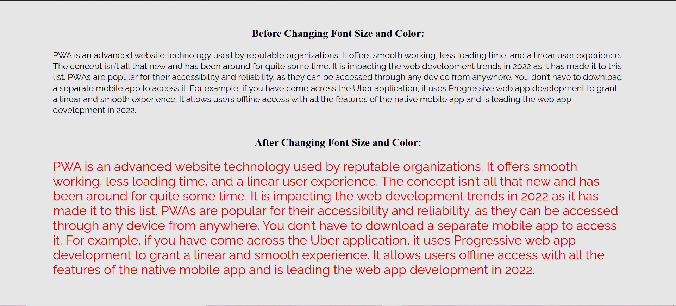

**TASK 3:** Write a css that places a background image halfway down the page, tiling it horizontally, the image should remain in place when the user scrolls up or down.

**CODE:**

<!DOCTYPE html>

<html lang="en">

<head>

    <meta charset="UTF-8">

    <meta http-equiv="X-UA-Compatible" content="IE=edge">

    <meta name="viewport" content="width=device-width, initial-scale=1.0">

    <link rel="stylesheet" href="style.css">

    <title>Task 03</title>

</head>

<body>

    <div class="container">

        <header>

            <h3>BAHRIA UNIVERSITY FUTURE CAMPUS</h3>

        </header>

    </div>

</body>

</html>

**CSS:**

{

    margin: 0;

    padding: 0;

}

body{

    height: 150vh;

}

h3{

    font-family: 'Metrophobic', sans-serif;

    font-size: 27px;

    color: brown;

    position: relative;

    top: 10px;

    left: 40px;

    text-decoration: underline;

    text-align: center;

}

.container{

    position: relative;

    top: 25%;

    height: 80vh;

    width: 100%;

    background-image: url(banner.png);

    background-size: cover;

    background-repeat: no-repeat;

    background-attachment: scroll;

    background-position: bottom;

}

**OUTPUT:**

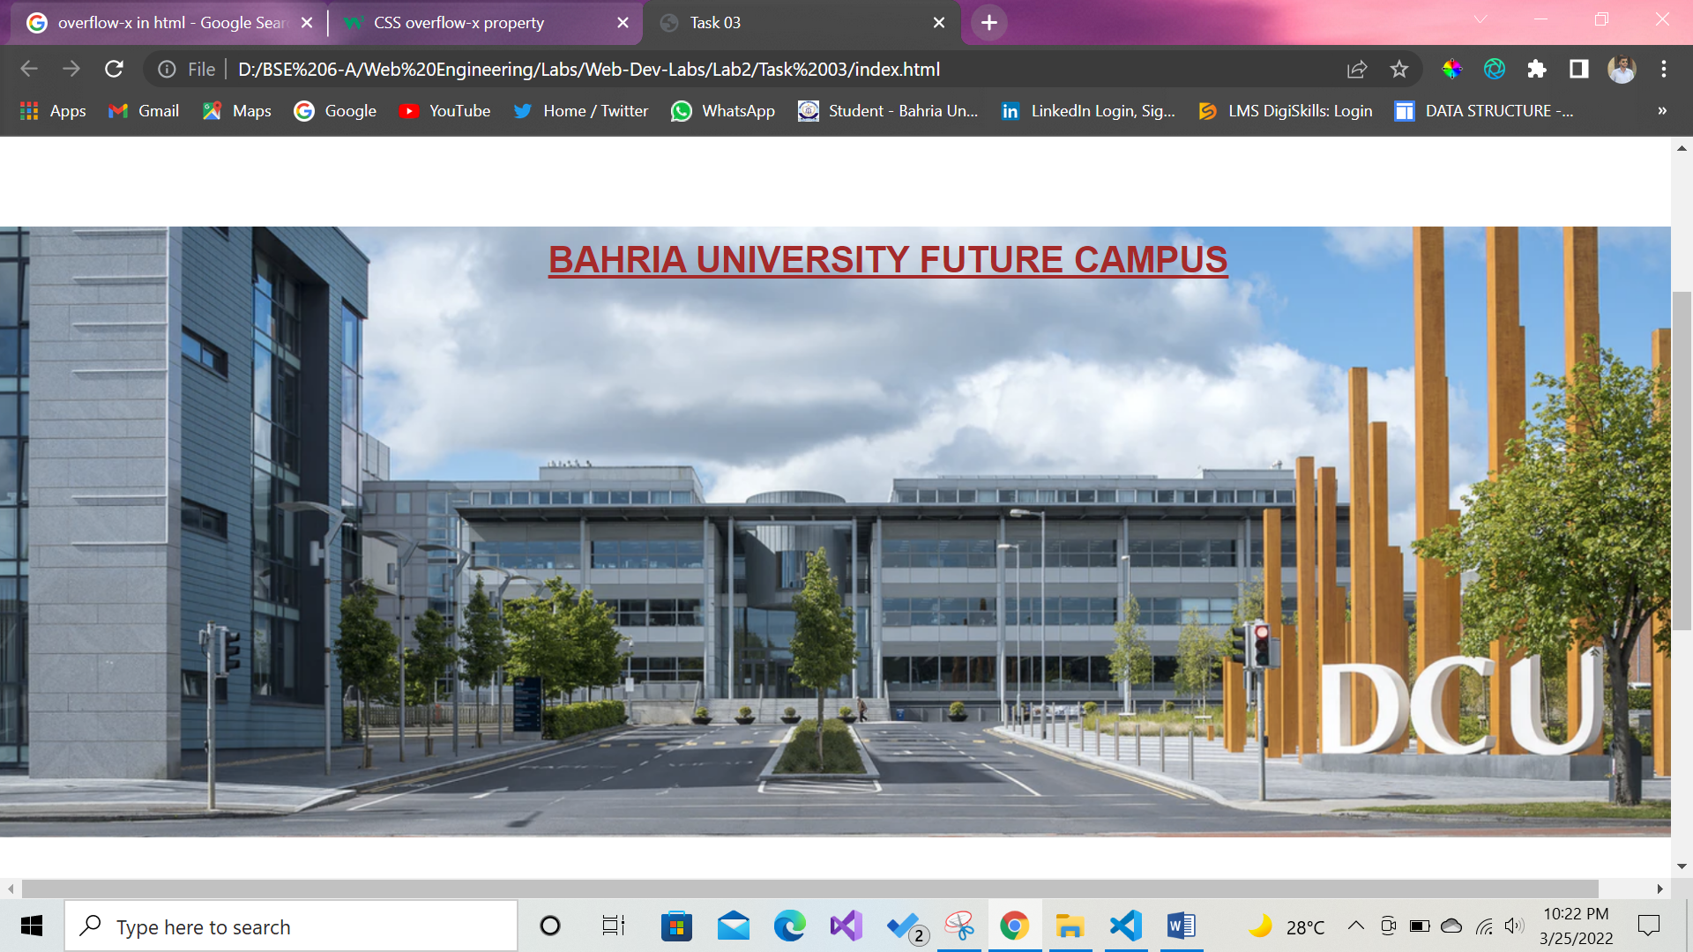

**TASK 4:** Write a css rule that gives all h1 and h2 elements a padding and margin of 0.5em, dashed border style.

**CODE:**

    <!DOCTYPE html>

<html lang="en">

  <head>

    <meta charset="UTF-8" />

    <meta http-equiv="X-UA-Compatible" content="IE=edge" />

    <meta name="viewport" content="width=device-width, initial-scale=1.0" />

    <title>Task 4</title>

    <style>

      h1,

      h2 {

        border: 2px dashed black;

        padding: 0.5em; /* Means 0.5 times the size of current fony */

        margin: 0.5em;

        display: block;

        width: 50%;

      }

    </style>

  </head>

  <body>

    <main>

      <h1>This is the first heading</h1>

      <h2>This is the second heading</h2>

    </main>

  </body>

</html>

**OUTPUT:**

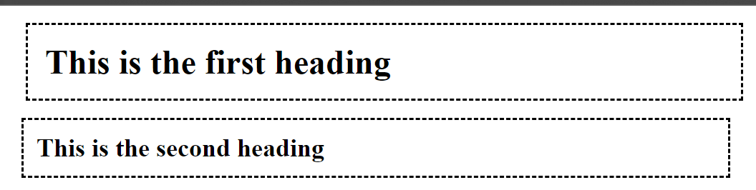

**TASK 5:** make a style sheet that display h1 in blue, in addition create a rule that displays all links in blue without underlining them. When the mouse hovers over a link, a change the links background color to yellow.

**CODE:**

  <head>

    <meta charset="UTF-8" />

    <meta http-equiv="X-UA-Compatible" content="IE=edge" />

    <meta name="viewport" content="width=device-width, initial-scale=1.0" />

    <title>Task5</title>

    <style>

      h1 {

        color: blue;

      }

      li {

        list-style: none;

        font-size: 19px;

      }

      a {

        text-decoration: none;

        transition: all 0.2s;

      }

      a:hover {

        /* color: yellow; */

        background-color: yellow;

      }

    </style>

  </head>

  <body>

    <h1>Here is Shoaib Shah's favorite Sites:</h1>

    <p>Click a name to visit this site.</p>

    <ul>

      <li><a href="#">Linkedin</a></li>

      <li><a href="#">Twitter</a></li>

      <li><a href="#"> Facebook</a></li>

      <li><a href="#">Instagram</a></li>

    </ul>

  </body>

</html>

**OUTPUT:**

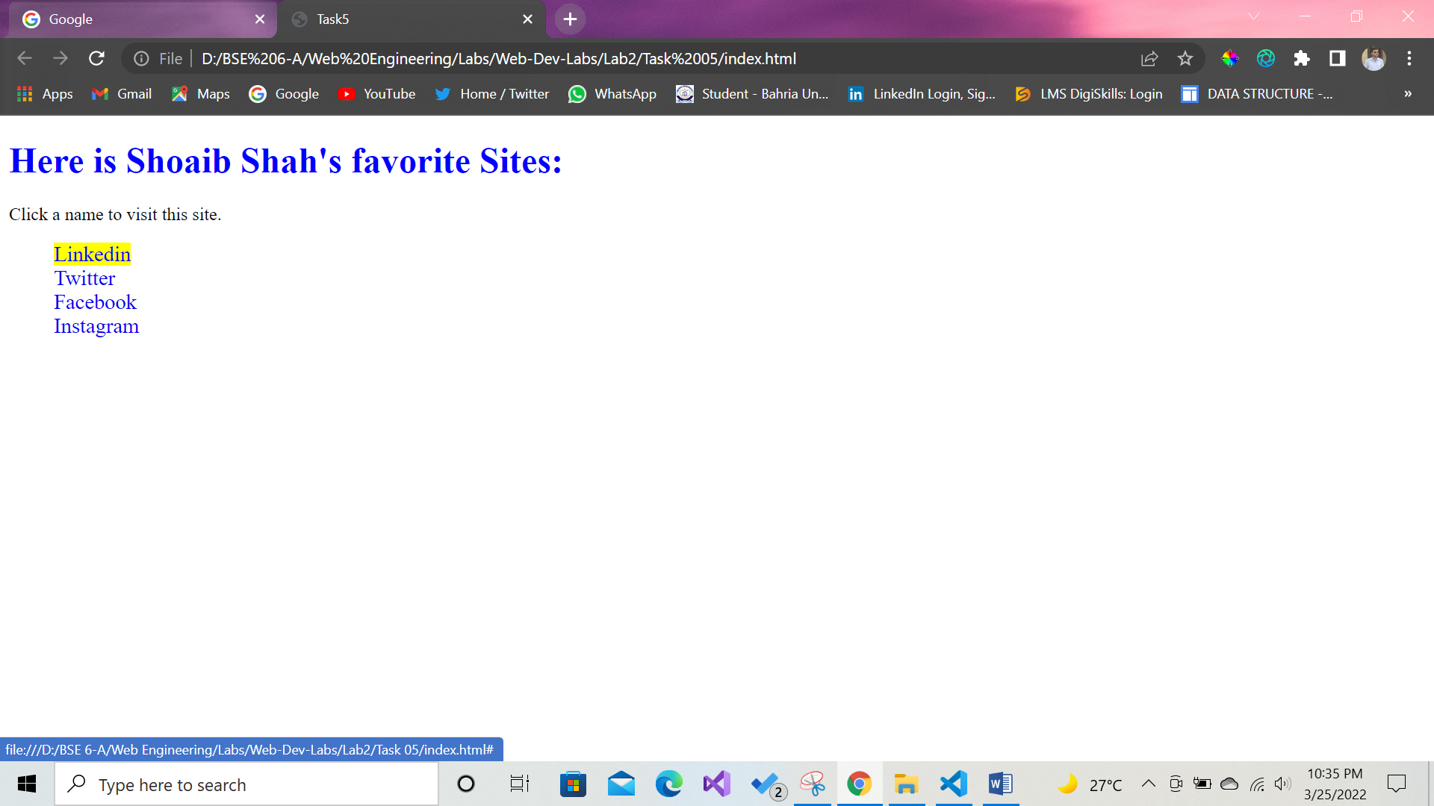

**TASK 6:** Make a navigation button with a link inside it, give it a border, background and text color, and make them change when the use of hovers the mouse over the button

**CODE:**

<!DOCTYPE html>

<html lang="en">

<head>

    <meta charset="UTF-8">

    <meta http-equiv="X-UA-Compatible" content="IE=edge">

    <meta name="viewport" content="width=device-width, initial-scale=1.0">

    <link rel="stylesheet" href="/CSS/style.css">

    <title>Task 06</title>

</head>

<body>

    <div class="container">

         <h3>NAVIGATION BUTTON:</h3>

        <div class="nav-button">

            <a href="www.google.com">Google</a>

        </div>

    </div>

</body>

</html>

**CSS:**

*{

    margin: 0;

    padding: 0;

}

body{

    height: 100vh;

}

.container{

    margin: 70px 80px;

}

h3{

    font-family: 'Metrophobic', sans-serif;

    font-size: 23px;

    margin-bottom: 30px;

    text-decoration: underline;

}

.nav-button a{

    font-family: 'Times New Roman', Times, serif;

    font-size: 20px;

    font-weight: 700;

    color: #fff;

    text-decoration: none;

    border: 1px solid #1f1f1f;

    border-radius: 10px;

    background-color: brown;

    padding: 12px 14px;

    letter-spacing: 0.7px;

}

.nav-button a:hover{

    color: black;

    background-color: rgb(66,133,244);

}

**OUTPUT:**

